**Coordinates never odd or even?**

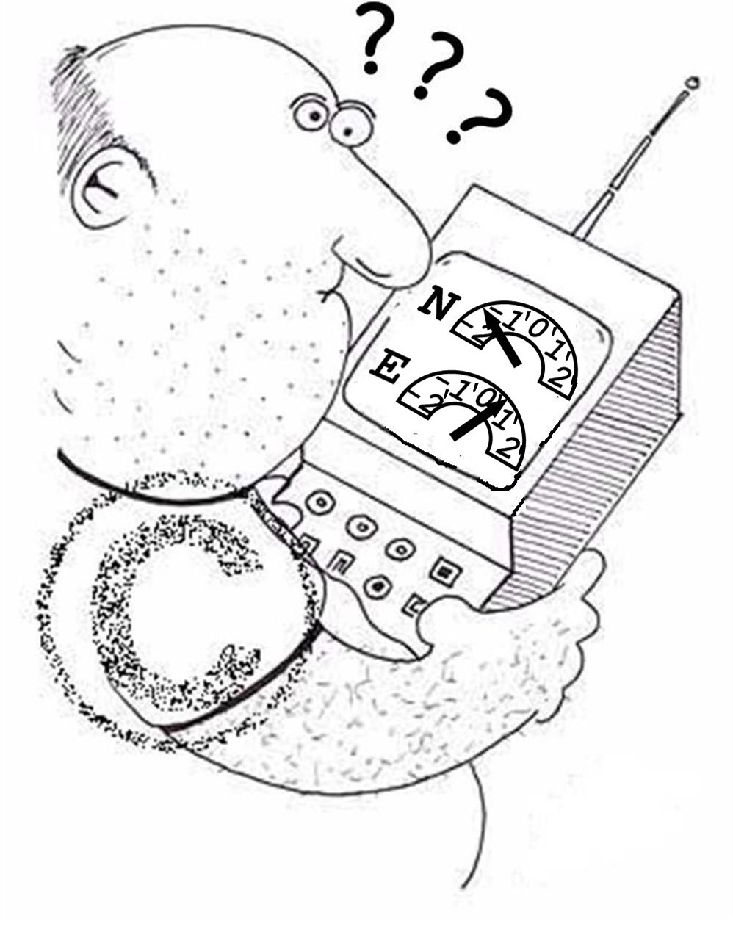

You can check your answer [here](http://geocheck.org/geo_inputchkcoord.php?gid=32295eefcf82-83bd-4186-ae97-8d7efebf0af9).

Additional hint(s):

Puzzle: try to find out what the title means. Combine your findings with the data presented on the meter above (take care of the units of measure!) and the coordinates listed on the cache page; The C on the shoulder of the man on the picture has no meaning; Don’t try to read the data on the meter accurately (they only make the solution unique);

Cache: on the other side of the water; Look at the bottom of the first (wooden) pole.